**FUTURE SALES PREDICTION**

Phase 5 submission document

**Project Title**: Future Sales Prediction

**Phase 5**: Project Documentation & Submission

**Topic**: In this phase you will document your project and prepare it for submission.



**Future Sales Prediction**

**Problem Statement:**

The problem is to create a predictive model for a retail company that can forecast future sales based on historical sales data. The goal is to help the company optimize its inventory management and make informed business decisions. This involves analyzing past sales trends, understanding the factors that influence sales, and using this information to predict future sales accurately.

**Introduction**:

* Predicting future sales is the heartbeat of successful business strategies. It involves the art and science of using historical data, market trends, and advanced analytical tools to forecast the demand for products or services in the days, months, or years to come.
* Sales prediction is not merely a crystal ball gazing exercise; it's a process that harnesses the power of data analytics, machine learning, and statistical modeling to unravel patterns and insights hidden within vast amounts of information. By analyzing past sales performance, consumer behavior, economic indicators, and various influencing factors, businesses can anticipate market trends and consumer demands, aiding in making well-informed decisions.
* The accuracy of future sales prediction can significantly impact inventory management, resource allocation, and the overall success of a business. In today's digital age, organizations are increasingly relying on sophisticated predictive models and algorithms to make proactive and data-driven decisions, allowing them to adapt swiftly to changing market conditions and stay ahead in the competitive landscape.
* However, the challenge lies in navigating uncertainties and unexpected variables that can influence sales trends. Future sales prediction requires a balance between data-driven insights and an understanding of the dynamic nature of markets, consumer behavior, and external influences.
* In essence, the ability to predict future sales is a cornerstone of strategic planning, enabling businesses to steer operations, marketing, and production in the right direction. As technology continues to evolve, refining predictive models becomes an ongoing journey toward greater accuracy and adaptability, ensuring businesses stay agile and responsive in an ever-changing market.

**Data source:**

Dataset link:

[Amazon Top 50 Bestselling Books 2009 - 2022 (kaggle.com)](https://www.kaggle.com/datasets/chriskachmar/amazon-top-50-bestselling-books-2009-2022)

Dataset:

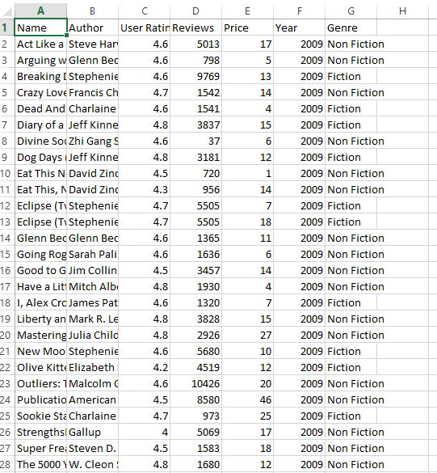

***Here’s is a list of tools and software commonly used in the process:***

1. **Programming Language:**

Python is the most popular language for machine learning due to its extensive libraries and frameworks. You can use libraries like Numpy, Pandas, scikit-learn, and more

1. **Integrated Development Environment(IDE):**

Choose an IDE for coding and running machine learning experiments. Some popular options include Jupyter Notebook, Google Colab, or traditional IDEs like PyCharm.

**3. Machine Learning Libraries:**

* You'll need various machine learning libraries, including:
* Scikit-learn for building and evaluating machine learning models.
* TensorFlow or PyTorch for deep learning, if needed.
* XGBoost, LightGBM, or CatBoost for gradient boosting models.

**4. Data Visualization Tools:**

Tools like Matplotlib, Seaborn, or Plotly are essential for data

exploration and visualization.

**5. Data Preprocessing Tools:**

Libraries like pandas help with data cleaning, manipulation, and preprocessing.

**6. Data Collection and Storage:**

Depending on your data source, you might need web scraping tools (e.g., BeautifulSoup or Scrapy) or databases (e.g., SQLite, PostgreSQL) for data storage.

**7. Version Control:**

Version control systems like Git are valuable for tracking changes in your code and collaborating with others.

**8. Notebooks and Documentation:**

Tools for documenting your work, such as Jupyter Notebooks or Markdown for creating README files and documentation.

**1. DESIGN THINKING AND PRESENT IN FORM**

**OF DOCUMENT**

**1. Empathize:**

* + Begin by understanding the retail company's specific pain points and objectives related to inventory management and sales forecasting.
  + Conduct interviews or surveys with stakeholders, including inventory managers, sales teams, and decision-makers, to gather their insights and requirements.
  + Explore the challenges they face in managing inventory efficiently and making data-driven decisions.

**2. Define:**

* Clearly define the problem statement based on the insights gathered. For example, "Develop a sales forecasting system to predict monthly sales for each product category in order to reduce overstock and understock situations."
* Identify the key performance indicators (KPIs) that will measure the success of the solution, such as inventory turnover rate or forecast accuracy.

**3. Ideate:**

* + Brainstorm potential solutions and approaches with a cross-functional team.
  + Consider the types of data needed, such as historical sales data, product attributes, external factors (e.g., holidays, promotions), and any relevant market data.
  + Explore various machine learning and forecasting models that could be suitable for the task.

**4. Prototype:**

* + Create a small-scale prototype or proof of concept to test the feasibility of the chosen approach.
  + Use a subset of historical data to build an initial model and evaluate its performance.
  + Gather feedback from stakeholders on the prototype to refine the approach.

**5. Test:**

* + Conduct thorough testing of the model using a validation dataset to assess its accuracy and reliability.
  + Evaluate different models and algorithms to determine which one performs best for the specific business problem.
  + Iterate on the model design based on test results and feedback.

**6. Implement:**

* Develop a full-scale solution that includes data pipelines, model training, and a user interface for accessing predictions.
* Ensure that the system is capable of handling large volumes of historical and real-time data efficiently.
* Deploy the system in a production environment, taking into account scalability and security considerations.

**7. Feedback and Iterate:**

* + Continuously collect feedback from end-users, inventory managers, and decision-makers regarding the accuracy and usefulness of the sales forecasts.
  + Monitor the system's performance in real-world scenarios and address any issues promptly.
  + Periodically retrain the model with new data to keep it up to date and improve accuracy.

**8. Scale and Optimize:**

* + As the system proves its value, consider scaling it to cover more product categories or regions within the company.
  + Optimize the system's efficiency and cost-effectiveness over time by fine-tuning algorithms and data processing pipelines.

**9. Educate and Train:**

* + Provide training to relevant staff members on how to use the sales forecasting system effectively.
  + Educate decision-makers on how to interpret and act upon the predictions to optimize inventory management.

**10. Celebrate Success:**

* + Acknowledge and celebrate the successes achieved through the implementation of the sales forecasting system, such as reduced inventory costs, improved product availability, and data-driven decision-making.

1. **DESIGN INTO INNOVATION**
2. **Data Collection:**

Data collection is a critical step in creating accurate predictive models for future sales. To predict future sales, you'll need various types of data that can offer insights into historical sales patterns, market trends, customer behaviour, and other relevant factors. Here are some crucial data collection areas:

1. **Data Preprocessing:**

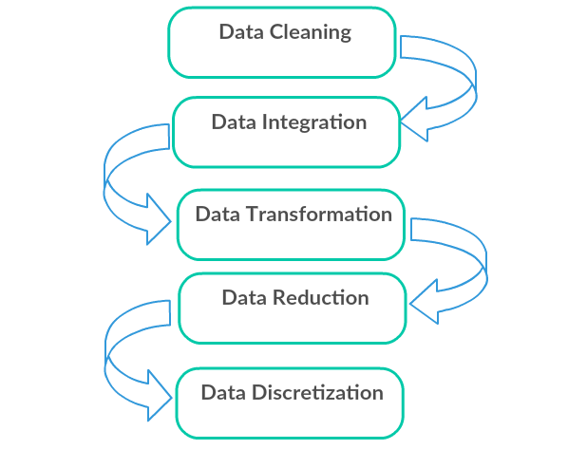Clean the data by handling missing values, outliers, and encoding categorical

variables. Standardize or normalize numerical features as necessary

Python Program:

import pandas as pd

from sklearn.preprocessing import StandardScaler

from sklearn.model_selection import train_test_split

from sklearn.preprocessing import StandardScaler

import matplotlib.pyplot as plt

import seaborn as sns

df = pd.read_csv("/content/bestsellers with categories.csv")

df.describe()

Check for missing values

print(df.isnull().sum())

Check the statistics of the DataFrame

Drop the 'User Rating' column from 'x'

x = df.drop('User Rating', axis=1)

Correct the syntax to drop the 'Reviews' column from 'y'

y = df['Reviews']

Fill missing values in 'x' using forward fill (ffill)

x.fillna(method='ffill', inplace=True)

Apply one-hot encoding to categorical columns in 'x'

x = pd.get_dummies(x, columns=['Author', 'Year', 'Genre'])

print(x)

from sklearn.model_selection import train_test_split

from sklearn.preprocessing import StandardScaler

Identify numeric columns for scaling

numeric_columns = x.select_dtypes(include= ['int64', 'float64']).columns

Split the data into training and testing sets

x_train, x_test, y_train, y_test = train_test_split(x, y, test_size=0.2, random_state=42)

Initialize the StandardScaler

scaler = StandardScaler()

Fit and transform the training data for numeric columns

x_train[numeric_columns] = scaler.fit_transform(x_train[numeric_columns])

Transform the testing data for numeric columns using the same scaler

x_test[numeric_columns] = scaler.transform(x_test[numeric_columns])

features = ['Name', 'Author', 'User Ratings', 'Reviews', 'Price', 'Year', 'Genre']

x_train_df = pd.DataFrame(x_train, columns=features)

y_train_df = pd.DataFrame({'Reviews': y_train})

print("pre-processed Data:")

print(x_train_df.head())

print("\n Target Data:")

print(y_train_df.head())

import matplotlib.pyplot as plt

import seaborn as sns

data = pd.read_csv('/content/bestsellers with categories.csv')

summary_stats = data.describe()

print("Summary Statistics:")

print(summary_stats)

coorelation_matrix = data.corr()

plt.figure(figsize=(10, 8))

sns.heatmap(coorelation_matrix, annot=True, cmap='coolwarm')

plt.title("Correlation Heatmap")

plt.show()

plt.figure(figsize=(8,6))

sns.histplot(data['Year'],kde=True,bins=30)

plt.title("Distribution of the publication year")

plt.xlabel("publication year")

plt.ylabel("Count")

plt.show()

plt.figure(figsize=(10,6))

sns.countplot(x='Genre', data=data, order=data['Genre'].value_counts().index)

plt.title("Count of Books by Genre") Correct the parameter name 'rotation'

plt.xticks(rotation=90)

plt.show()

plt.figure(figsize=(2,3))

sns.catplot(x='Genre', y='User Rating', hue='Author', kind='strip', data=data)

plt.xticks(rotation=90) Rotate x-axis labels for better readability

plt.show()

plt.figure(figsize=(10,8))

sns.boxplot(x='Genre',y='Price',data=data)

plt.title("Book price by Genre")

plt.show()

*Output:*

*Checking missing values*

*Name 0*

*Author 0*

*User Rating 0*

*Reviews 0*

*Price 0*

*Year 0*

*Genre 0*

*dtype: int64*

*checking for outliers:*

*Name Reviews Price*

*0 Act Like a Lady, Think Like a Man: What Men Re... 5013 17*

*1 Arguing with Idiots: How to Stop Small Minds a... 798 5*

*2 Breaking Dawn (The Twilight Saga, Book 4) 9769 13*

*3 Crazy Love: Overwhelmed by a Relentless God 1542 14*

*4 Dead And Gone: A Sookie Stackhouse Novel (Sook... 1541 4*

*.. ... ... ...*

*695 The Wonderful Things You Will Be 20920 9*

*696 Ugly Love: A Novel 33929 10*

*697 Verity 71826 11*

*698 What to Expect When You're Expecting 27052 13*

*699 Where the Crawdads Sing 208917 10*

Author_Abraham Verghese Author_Adam Gasiewski Author_Adam Mansbach \

0 0 0 0

1 0 0 0

2 0 0 0

3 0 0 0

4 0 0 0

.. ... ... ...

695 0 0 0

696 0 0 0

697 0 0 0

698 0 0 0

699 0 0 0

Author_Adam Silvera Author_Adam Wallace Author_Adir Levy \

0 0 0 0

1 0 0 0

2 0 0 0

3 0 0 0

4 0 0 0

.. ... ... ...

695 0 0 0

696 0 0 0

697 0 0 0

698 0 0 0

699 0 0 0

Author_Admiral William H. McRaven ... Year_2015 Year_2016 Year_2017 \

0 0 ... 0 0 0

1 0 ... 0 0 0

2 0 ... 0 0 0

3 0 ... 0 0 0

4 0 ... 0 0 0

.. ... ... ... ... ...

695 0 ... 0 0 0

696 0 ... 0 0 0

697 0 ... 0 0 0

698 0 ... 0 0 0

699 0 ... 0 0 0

Year_2018 Year_2019 Year_2020 Year_2021 Year_2022 Genre_Fiction

0 0 0 0 0 0 0

1 0 0 0 0 0 0

2 0 0 0 0 0 1

3 0 0 0 0 0 0

4 0 0 0 0 0 1

.. ... ... ... ... ... ...

695 0 0 0 0 1 1

696 0 0 0 0 1 1

697 0 0 0 0 1 1

698 0 0 0 0 1 0

699 0 0 0 0 1 1

Genre_Non Fiction

0 1

1 1

2 0

3 1

4 0

.. ...

695 0

696 0

697 0

698 1

699 0

[700 rows x 324 columns]

pre processed - Data:

Name Author User Ratings \

82 The Five Dysfunctions of a Team: A Leadership ... NaN NaN

51 Autobiography of Mark Twain, Vol. 1 NaN NaN

220 Knock-Knock Jokes for Kids NaN NaN

669 Principles for Dealing with the Changing World... NaN NaN

545 Unicorn Coloring Book: For Kids Ages 4-8 (US E... NaN NaN

Reviews Price Year Genre

82 -0.664098 -0.699680 NaN NaN

51 -0.776559 0.122609 NaN NaN

220 -0.644803 -0.905253 NaN NaN

669 -0.72712 0.842113 NaN NaN

545 -0.543977 -0.905253 NaN NaN

**Target Data:**

Reviews

**Summary Statistics:**

User Rating Reviews Price Year

count 700.000000 700.000000 700.000000 700.000000

mean 4.639857 19255.195714 12.700000 2015.500000

std 0.218586 23613.443875 9.915162 4.034011

min 3.300000 37.000000 0.000000 2009.000000

25% 4.500000 4987.250000 7.000000 2012.000000

50% 4.700000 10284.000000 11.000000 2015.500000

75% 4.800000 23358.000000 15.000000 2019.000000

max 4.900000 208917.000000 105.000000 2022.000000

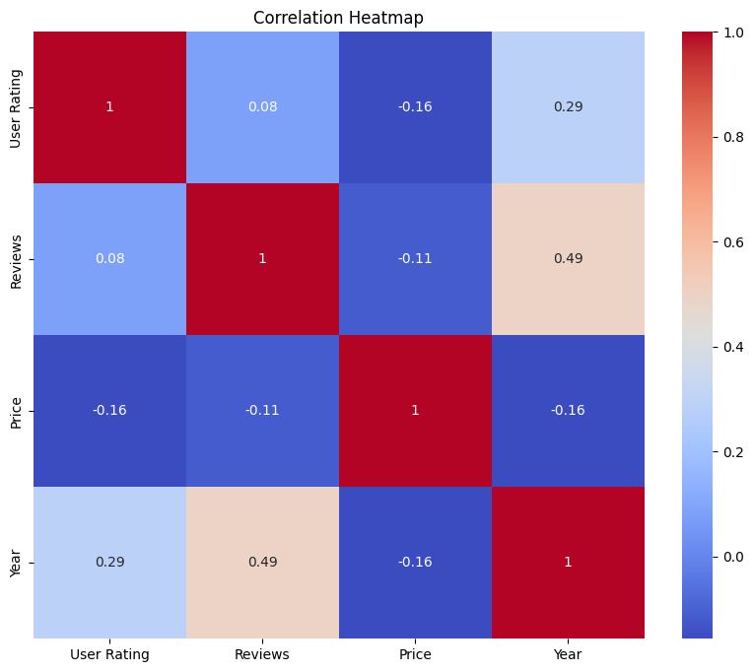

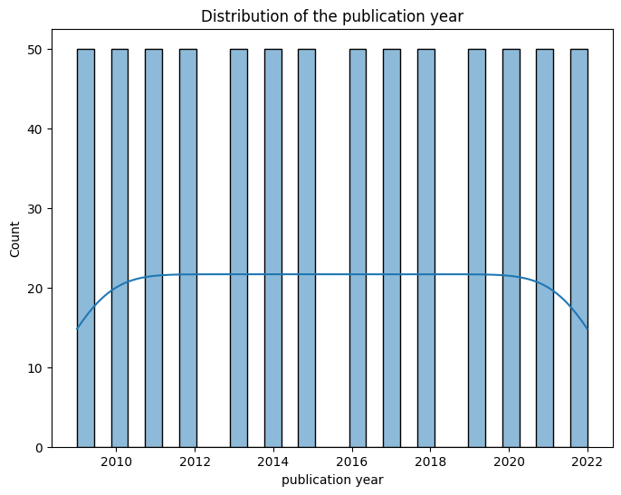

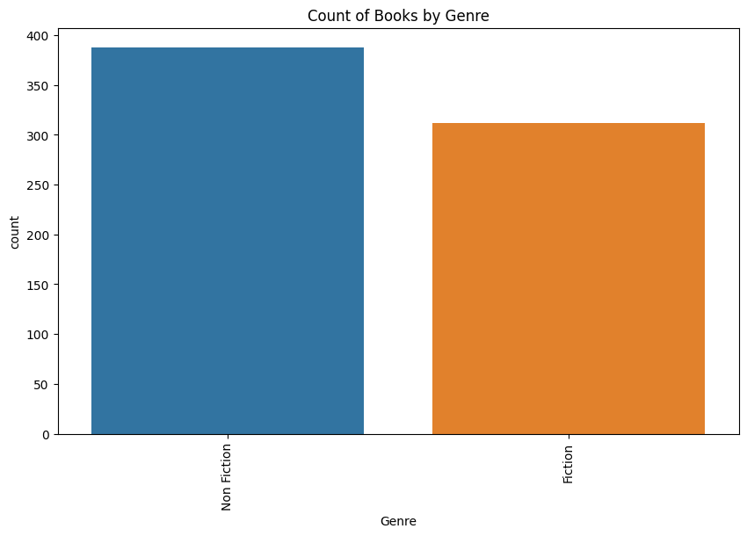

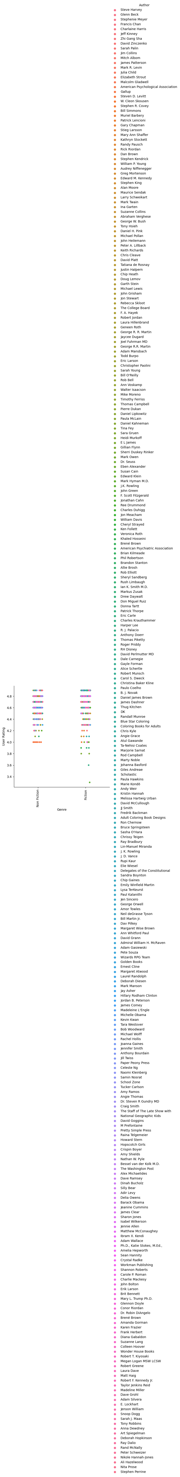

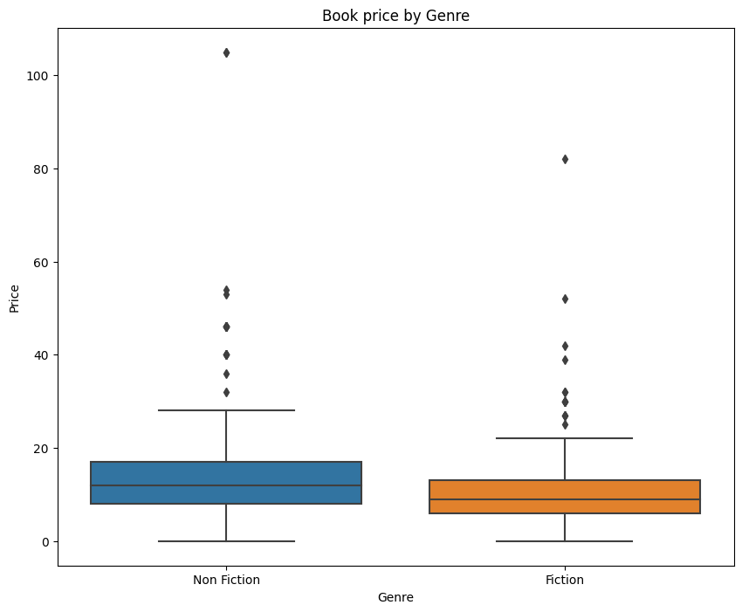

1. **Feature Engineering:**

Feature engineering for LSTM involves creating sequences of data. LSTM models are capable of learning patterns from sequential data. In the case of sales forecasting, you might do the following:

**Sequence Creation:**

Organize your sales data into sequences. Each sequence could represent a window of historical sales data.

**Normalization:**

Normalize the data to ensure the LSTM model converges faster. You can use Min-Max scaling or standardization.

**Input Features and Targets:**

Create input features (X) and corresponding targets (y). For example, X could be a sequence of past sales values, and y could be the next sales value.

**Look-Back Period:**

Decide on the look-back period, which is the number of past time steps the model should consider when making a prediction.

1. **Feature Selection:**

Selecting relevant features for sales prediction involves understanding the factors influencing sales. Common features include historical sales data, seasonality, marketing efforts, economic indicators, and product characteristics. Techniques like correlation analysis, feature importance from machine learning models, and domain knowledge help identify significant predictors. Focus on relevant historical data, market trends, promotional activities, and product attributes to enhance the predictive accuracy.

1. **Model Selection:**

For future sales prediction, consider models like linear regression for simple trends, ARIMA for time-series patterns, or machine learning methods (random forests, gradient boosting) for complex relationships. Choose based on data characteristics, problem complexity, and desired accuracy vs. interpretability trade-offs.

1. **Model Trainning:**

To train an LSTM model for top-selling book sales prediction:

1. Preprocess data: Collect historical sales data, create sequences of sales with features like publication date.

2. Split data into training and testing sets.

3. Normalize data.

4. Build an LSTM model with appropriate architecture.

5. Compile the model with loss function and optimizer.

6. Train the model on the training data, tuning hyperparameters.

7. Evaluate the model using metrics like MSE on the testing data.

8. Use the trained model to make future sales predictions based on new inputsequences.

1. **Evaluation Metrics:**

For evaluating book sales prediction models, use regression metrics like Mean Absolute Error (MAE), Mean Squared Error (MSE), Root Mean Squared Error (RMSE), and R-squared (R²) score.

MAE measures the average prediction error, MSE emphasizes larger errors, RMSE provides a more interpretable error measure, and R² measures the model's explanatory power.

Lower MAE, MSE, and RMSE and higher R² indicate better model performance.

Evaluate your model using these metrics to assess its accuracy and predictive power.

***Python program for feature engineering ,model training and Evaluation***

Import necessary libraries

import pandas as pd

import numpy as np

from sklearn.preprocessing import MinMaxScaler

from tensorflow.keras.models import Sequential

from tensorflow.keras.layers import LSTM, Dense

from sklearn.model_selection import train_test_split

import matplotlib.pyplot as plt

Load your dataset

data = pd.read_csv('/bestsellers with categories.csv') Replace with your dataset file

Feature Engineering

Normalize numerical features

scaler = MinMaxScaler()

numerical_cols = ['User Rating', 'Reviews', 'Price', 'Year']

data[numerical_cols] = scaler.fit_transform(data[numerical_cols])

Encode categorical feature 'Genre' (you can use one-hot encoding)

data = pd.get_dummies(data, columns=['Genre'])

Define your target variable

target_col = 'User Rating’ Replace with the actual variable you want to predict

Create sequences of data

sequence_length = 10 Adjust as needed

X = []

y = []

for i in range(len(data) - sequence_length):

X.append(data[numerical_cols + list(data.columns[8:])].iloc[i:i+sequence_length].values)

y.append(data[target_col].iloc[i+sequence_length])

X = np.array(X)

y = np.array(y)

Split the data into training and testing sets

X_train, X_test, y_train, y_test = train_test_split(X, y, test_size=0.2, random_state=42)

Build the LSTM model

model = Sequential()

model.add(LSTM(50, input_shape=(X_train.shape[1], X_train.shape[2])))

model.add(Dense(1)) Adjust for the number of output neurons based on your problem

Compile the model

model.compile(loss='mean_squared_error', optimizer='adam')

Train the model

model.fit(X_train, y_train, epochs=10, batch_size=12, validation_data=(X_test, y_test))

Evaluate the model

test_loss = model.evaluate(X_test, y_test)

print(f'Test Loss: {test_loss}')

Make predictions

y_pred = model.predict(X_test)

print("y_prediction:",y_pred)

Visualize the results

plt.figure(figsize= (12, 6))

plt.plot(y_test, label='Actual')

plt.plot(y_pred, label='Predicted')

plt.legend()

plt.show()

from sklearn.metrics import mean_squared_error,r2_score

mse=mean_squared_error(y_test,y_pred)

r2=r2_score(y_test,y_pred)

print(“Metrics:”)

print("MEAN SQUARED ERROR:",mse)

print("R2-SCORE:",r2)

***Output:***

***Model Training:***

Epoch 1/10

46/46 [==============================] - 3s 17ms/step - loss: 0.0711 - val_loss: 0.0242

Epoch 2/10

46/46 [==============================] - 0s 7ms/step - loss: 0.0188 - val_loss: 0.0203

Epoch 3/10

46/46 [==============================] - 0s 6ms/step - loss: 0.0183 - val_loss: 0.0210

Epoch 4/10

46/46 [==============================] - 0s 7ms/step - loss: 0.0182 - val_loss: 0.0195

Epoch 5/10

46/46 [==============================] - 0s 6ms/step - loss: 0.0184 - val_loss: 0.0199

Epoch 6/10

46/46 [==============================] - 0s 7ms/step - loss: 0.0179 - val_loss: 0.0207

Epoch 7/10

46/46 [==============================] - 0s 6ms/step - loss: 0.0182 - val_loss: 0.0198

Epoch 8/10

46/46 [==============================] - 0s 6ms/step - loss: 0.0179 - val_loss: 0.0192

Epoch 9/10

46/46 [==============================] - 0s 7ms/step - loss: 0.0179 - val_loss: 0.0204

Epoch 10/10

46/46 [==============================] - 0s 7ms/step - loss: 0.0181 - val_loss: 0.0198

5/5 [==============================] - 0s 4ms/step - loss: 0.0198

Test Loss: 0.019775712862610817

5/5 [==============================] - 0s 6ms/step

**y_prediction:** [[0.8171518 ]

[0.8755395]

[0.82673275]

[0.8581269]

[0.8709007]

[0.8189731]

[0.91319305]

[0.7752176]

[0.8721105]

[0.82245994]

[0.9001946 ]

[0.789292]

[0.90959436]

[0.8086507 ]

[0.90822536]

[0.9120763]

[0.85243064]

[0.8485834]

[0.9008284]

[0.89121807]

[0.8747343]

[0.8635044]

[0.8528505]

[0.92204547]

[0.82419074]

[0.86484116]

[0.84327435] [0.7756054] [0.9286332 ]……..]

**Actual Vs Predicted**

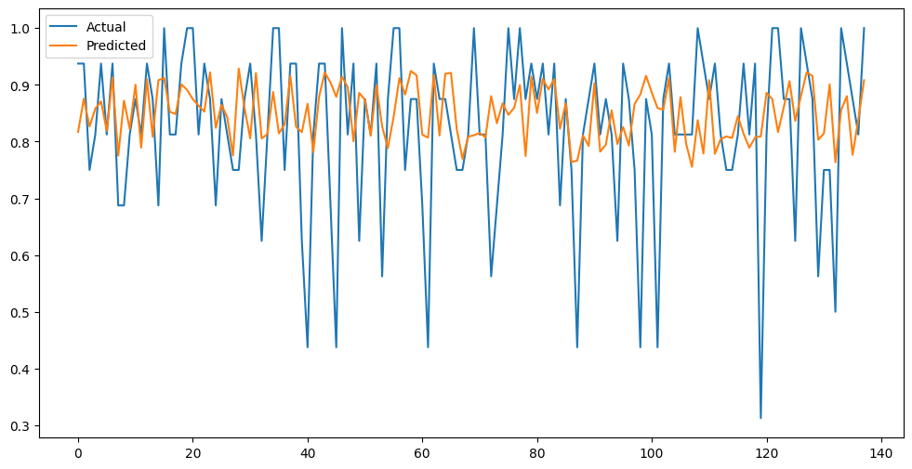

**Metrics:**

**MEAN SQUARED ERROR**: 0.019775712297464994

**R2-SCORE:** 0.03566001942258268

**Conclusion:**

In conclusion, a successful future sales prediction project hinges on selecting appropriate models (e.g., regression, time series, machine learning), understanding and utilizing relevant features (historical sales, marketing efforts, economic indicators), and prioritizing accuracy while balancing interpretability. Integrating domain knowledge and iterative model refinement are crucial for optimal forecasting results in sales prediction projects.